EGR-289

Final Project: Portable GPS with Physical time element

Lab Report

Harnoor Singh

Abstract–one sentence

This device combines GPS for real-time location display on a screen with a servo mechanism for physical time indication, and offers a versatile solution for dynamic time and location representation.

Problem statement

The problem lies in the need for a device that seamlessly integrates GPS technology to provide real-time location display on a screen while incorporating a servo mechanism for physical time indication, as the current market lacks a comprehensive solution that offers customizable options for both form factor and durability.

Description

This device integrates GPS technology to display real-time location on a screen while utilizing a servo mechanism to physically indicate the current time, offering a multitude of ways to show time and location, and allows users to manipulate the size and durability of the device.

Pictures

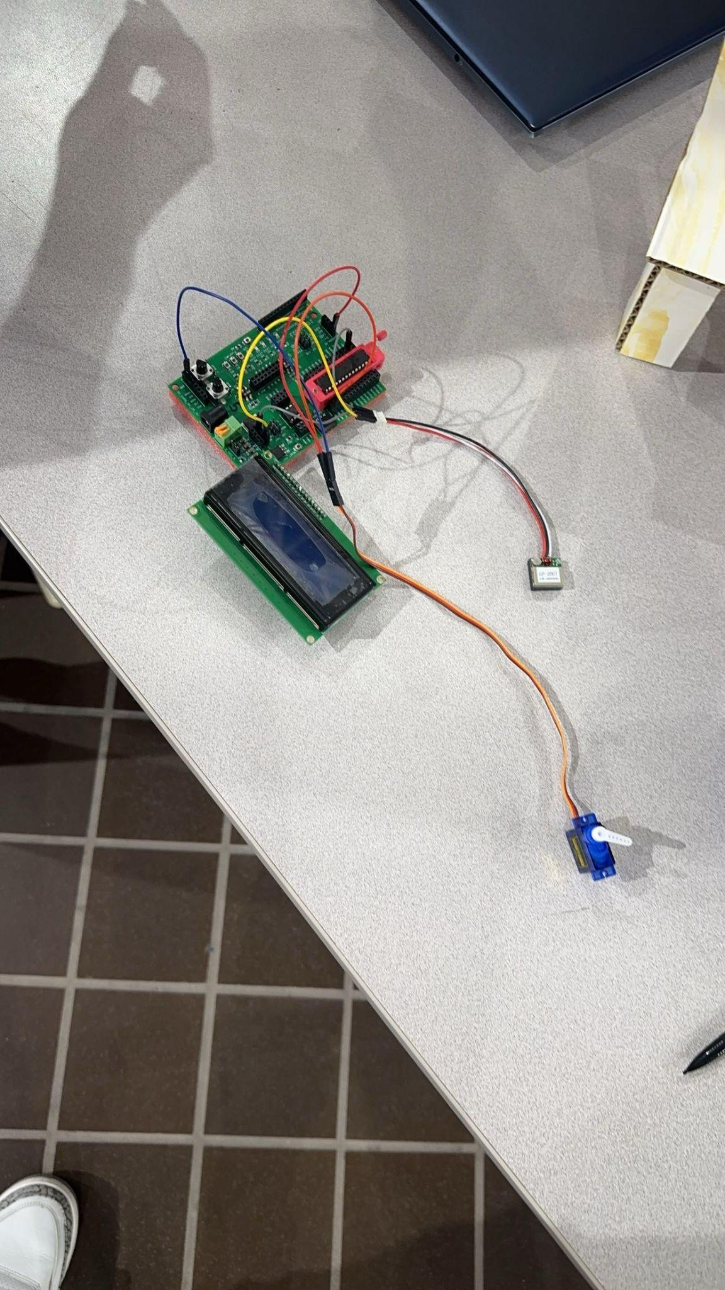

Code

#include <avr/io.h>

#include <util/delay.h>

#include <avr/interrupt.h>

#include "c:\avr\freq_328.h"

#include "c:\avr\i2c.h"

#include "c:\avr\lcd_16x2_i2c.h"

char serial_receive();

void print_info(char* data, int& h, int& m) ;

void cycle(int);

int main(void) {

DDRB = 0b1110;

class lcd_16x2_i2c lcd;

freq_8mhz();

UBRR0H = 0;

UBRR0L = 103;

UCSR0A |= (1 << U2X0);

UCSR0B |= (1 << RXEN0);

char a;

do {

a = serial_receive();

} while (a != '$');

const int n = 80;

char c[100];

for (int i = 0; i < n; i++) {

c[i] = serial_receive();

}

int ho, mi;

print_info(c, ho, mi);

cycle(ho);

/*

while (1) {

for (int i = 0; i < 100; i++) {

PORTB = 0b1111;

_delay_ms(2000);

PORTB = 0b0111;

_delay_ms(2000);

PORTB = 0b0011;

_delay_ms(2000);

PORTB = 0b1001;

_delay_ms(2000);

}

//int rotated_value_ho = 360 * ho;

*/

_delay_ms(5000); // 5-second pause

cycle(mi);

/*

for (int i = 0; i < 100; i++) {

PORTB = 0b1111;

_delay_ms(2000);

PORTB = 0b0111;

_delay_ms(2000);

PORTB = 0b0011;

_delay_ms(2000);

PORTB = 0b1001;

_delay_ms(2000);

}

// int rotated_value_mi = 360 * mi;

_delay_ms(1000);

}

*/

return 0;

}

char serial_receive() {

while ((UCSR0A & (1 << RXC0)) == 0);

int value = UDR0;

return static_cast<char>(value);

}

void print_info(char* data, int& h, int& m)

{

class lcd_16x2_i2c lcd;

int comma_count = 0;

int i = 0;

while (comma_count < 1)

{ if (data[i] == ',') comma_count++;

i++;

}

h = (data[i ]-0x30)*10 + (data[i+1]-0x30);

m = (data[i+2]-0x30)*10 + (data[i+3]-0x30);

lcd.dd(h);

lcd.dd(m);

}

void cycle(int time){

int i = 0;

while (i < time){

for (int i = 0; i < 200; i++){

PORTB = 0b10;

_delay_ms(1);

PORTB = 0b00;

_delay_ms(19);

}

i++;

if (i == time)

return;

for (int i = 0; i < 200; i++){

PORTB = 0b10;

_delay_ms(2);

PORTB = 0b00;

_delay_ms(19);

}

i++;

}

}